**The pattern is constructed based on three different rules**.

1. The second rule is that the number in its row have a constant sum. Mining that if $x\left(i\right)$, $y\left(i\right)$, $z\left(i\right)$ are the numbers of the row $i$, then $x\left(i\right)+y\left(i\right)+z\left(i\right)=c$, where $c$ is chosen randomly from the integers in (10,30). Another way will be to have c be a function of $i$. This will make the riddle harder so for when i add levels in the game.

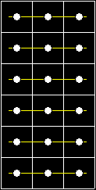

1. The first one is that the pattern will repeat itself every two rows. That way to find the answer you will only need to do calculations with the numbers in the row directly above the last one. The rest of the matrix is used to find the hidden pattern.

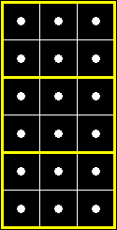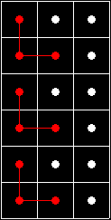

constant sum. If the sum of the numbers in its row is $a$ and the sum of the numbers in the red dots is $b$, then the numbers that don’t belong to the specified pattern (of every two rows) will have a sum of $2a-b$. That’s why its important to always chose $b<2a$.

1. The last rule is that every two rows there will be three specific cells that the numbers that they will contain will have a constant sum. In the example of the picture in the right the numbers in the red dots that are connected with the red lines will have a sum of 25. The cells that will be part of this pattern are chosen randomly as well as the number that are summing to. It’s very easy to prove that the numbers that don’t belong in this pattern will also have a

Based on these rules now the program will construct the matrix. Obviously to find the answer the user will eventually have to solve a 2x3 set of equations. Now because the numbers in the matrix are chosen randomly there is no actual way to know for sure if the set of equations will always have a solution. So, because depending on the numbers the riddle is possible to not have a solution, the program is designed to search for different (randomly chosen) numbers, until it finds one that can be solved.

Another important think to note is that because the set of equations is 2x3, if it has a solution it will not be singular. That’s because this is meant to be the first level of the game. In later levels additional rules will be anted that will make the riddle harder to solve and the set of equation 3x3 and hence with a singular solution (when it has one).